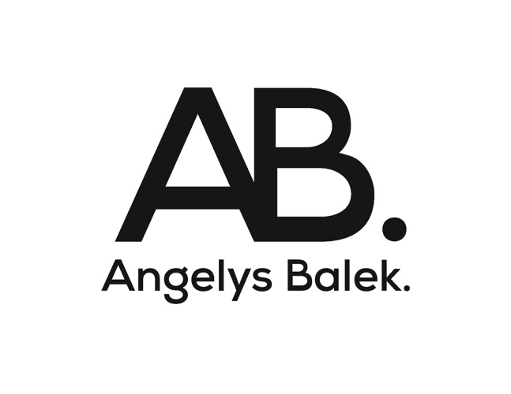
FALL / WINTER 2018 COLLECTION

New York, NY – Designer and artist Angelys Balek continues her romantic adventure between art and fashion in her Fall/Winter 2018 collection. Unifying swimwear, activewear, and athleisure, Balek’s latest collection tells a story of liberation and individualism through nature-inspired prints, rich colors, and bold silhouettes.
Celebrating Balek’s Thai roots, FW18 finds inspiration in Phuket’s rich antiquity and vibrant Sino-Portuguese history. Balek’s opulent multicultural vision this season symbolizes a new versatility in the pieces offered with this collection. Hand-painted prints, bold shapes, and vibrant colors are focal points of this collection. Tops, bras, and leggings—all in Balek’s signature prints and unique color blocking—feature prominently in AB’s activewear range. FW18 also introduces a line of accessories: cross-body bags, headbands, and hats to complement Balek’s dynamic designs and fulfil ones amphibious and metamorphic lifestyle.
It is Balek’s meticulous technique and detailing that draws attention from the unison of western and eastern cultures that makes this collection one-of-a-kind. Balek’s artistic technique, hand-painted prints, and bold use of color make this collection truly special. Balek strives to expand her brand story and heritage with her iconic nature-inspired glamour.
Fall/Winter 2018 is an ecstatic vision of liberation and individualism that are shown by the brand’s emblematic handcrafted prints. A celebration of individual style and glamour, each piece in this collection is a work of art and reveals a story of the resilient woman and her coming of age. Angelys Balek invites you to step into her element known as the #ABworld and discover her unique vision—and what it means to be a free spirit.
For more information, please contact:
Press@AngelysBalek.com
Angelys Balek
83 Mercer Street
New York, NY 10012
Tel: +1.617.407.6520

