For immediate release:

Asia’s fashion showcase CENTRESTAGE draws to a close
7,700 buyers visited, more than double compared to last year

9 September 2023 – Asia’s premier fashion event CENTRESTAGE, organised by the Hong Kong Trade Development Council (HKTDC) with Create Hong Kong (CreateHK) of the Government of the Hong Kong Special Administrative Region (HKSAR)* as the Lead Sponsor, concluded successfully yesterday. Due to extreme weather conditions, the fair was temporarily suspended on Friday, 8 September. However, over the course of three days of exhibition, it still attracted more than 7,700 buyers from 78 countries and regions visiting and make purchase. This number is 2.8 times that of last year and has increased by 10% compared to pre-pandemic levels in 2019. Notably, buyers from the Middle East, Mainland China, and ASEAN countries recorded significant growth, affirming the exhibition as an international platform for promoting and launching fashion brands.

HKTDC Deputy Executive Director Sophia Chong said: “CENTRESTAGE brought together fashion brands from all over the world and serves as an important platform for promotion, trade and exchange in Asia. We actively invited local and overseas buyers to visit the show, including well-known retailers and buyers from France, the United Kingdom, Germany, Japan, Indonesia, and more. Our goal is to assist local brands in entering the international market and expand their business footprint. CENTRESTAGE stays closely attuned to global trends and, in this year’s fair, has infused a substantial amount of digital fashion and sustainable development elements. We also provided valuable platforms for fostering the exchange of ideas, joining forces with the industry to drive innovation.”

60% industry players expect growth in 1 to 2 years

To gauge industry sentiment regarding the fashion industry's outlook and product trends, the HKTDC conducted on-site surveys during CENTRESTAGE, interviewing 350 exhibitors and buyers alike.

According to the survey results, 67% of respondents believe that fashion products designed in Hong Kong are in-line with those in developed markets. Additionally, 82% respondents stated Hong Kong is their top choice for physical trade fairs. This reflects Hong Kong’s significant position in the global fashion industry.

Most respondents hold an optimistic view of overall sales in 2024. Around 60% of the respondents anticipate growth in sales within the next 12 to 24 months, while 37% even expect an increase within 6 to12 months.

As business travel activities gradually resume, 30% of participants anticipate the return of business growth to pre-pandemic growth levels within a year, while 26% believe it may take a year and half.

Both the rise in demand in emerging markets and the recovering of consumer purchasing power are seen as the major business opportunities this year, with approximately 45% of the respondents expressing this belief for each aspect. Simultaneously, over 60% perceive the fluctuations of global economy as the major challenge of the year.

Although the pandemic has undoubtedly impacted business operations, it has also accelerated the widespread move to online channels. According to the survey, 39% of respondents reported that half or above of their sales/purchases over the past 6 months were conducted online. Moreover, 53% of participants anticipate that half or above of their sales/purchases will take place through online channels in the next 2 years. 20% of the respondents named hktdc.com Sourcing as their top online trading platforms used in the past 6 months.

Industry highlights the importance of sustainability
The survey revealed a growing emphasis on sustainable fashion, with 74% of respondents agreed sustainable fashion would be prevalent in the fashion industry in 2023.

CENTRESTAGE's closing day was opened to the public, in addition to buyers. More than 30 fashion shows and events were organised throughout the fair, attracting enthusiastic participation from both industry professionals and the general public. HKTDC partnered with various organisations to host events promoting sustainable development in the industry. The fair also featured the participation of multiple local and international fashion brands that embrace sustainable practices.

CENTRESTAGE has successfully created business opportunities for exhibitors and buyers. Established in 2019, the Hong Kong sportswear brand ARTY:ACTIVE produces clothing using 100% recycled fiber materials. Through CENTRESTAGE, the brand has connected with mainland China customers in the past, providing them with clothing design services. It has also successfully entered the Malaysian market through another HKTDC event. The brand returned to CENTRESTAGE this year and achieved satisfying results. Founder Gary Tsang stated, "Our aim was to promote our brand and expand into the international market. We are pleased to share that among the buyers we met at the fair, eight buyers from Thailand, South Korea, Cambodia, and Vietnam are planning to place orders, resulting in a total business value reaching a seven-figure amount in Hong Kong dollars. We have successfully accomplished all the goals we set for our participation."

Liu Xinyi, the Head of Buying of Chongqing’s S.N.D Ltd., expressed that her visit to CENTRESTAGE exceeded expectations. She mentioned, "In the past, we primarily focused on attending fashion weeks in Paris, Milan and Shanghai. This year marked my first time participating in CENTRESTAGE, and I was pleasantly surprised to discover a multitude of emerging design talents. The works of the students were incredibly stunning and mature. Additionally, I had the opportunity to meet with eight designers from Hong Kong, Japan, and Korea through business matchmaking meetings. I plan to maintain contact with four of them, as it opens up new partnership opportunities for us."

Photo download: https://bit.ly/3Likul3
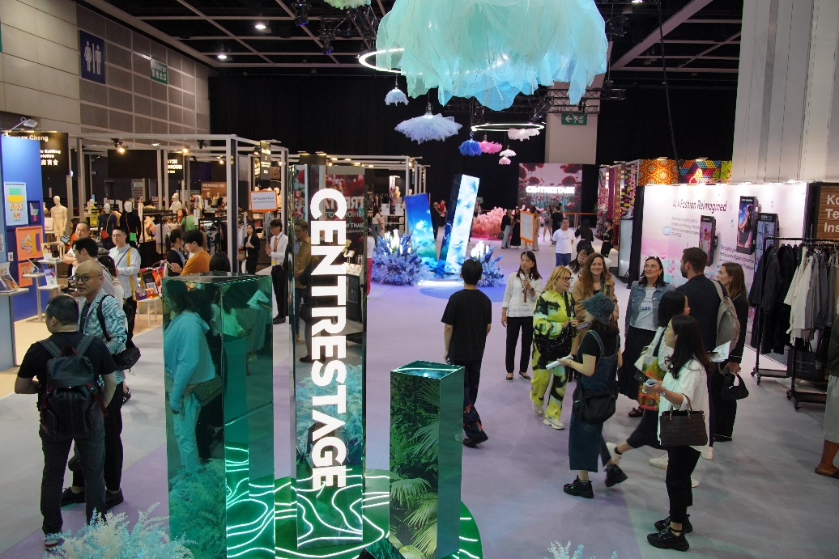
The eighth edition of CENTRESTAGE brought together more than 240 fashion brands from 19 countries and regions, attracting more than 7,700 trade buyers to visit and make purchase.
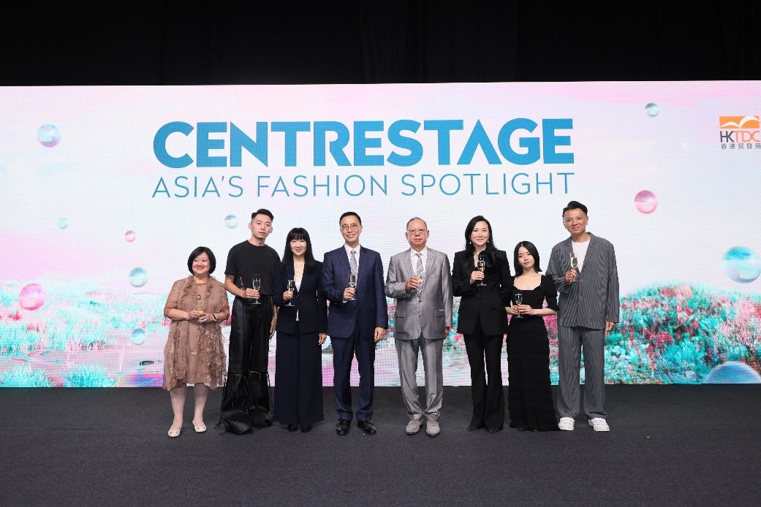
Joining CENTRESTAGE opening ceremony are (from left) Shirley Chan, Council Member, HKTDC; Wilson Choi, Hong Kong designer and Founder of REDEMPTIVE; Margaret Fong, Executive Director, HKTDC; Kevin Yeung, Secretary for Culture, Sports and Tourism of the Government of the HKSAR; Dr Peter K N Lam, Chairman, HKTDC; Katherine Fang, Chairman, HKTDC Garment Advisory Committee 2023/2024; Emi Funayama, Japanese designer and Founder of FETICO; and Sunny Tan, Member of the Legislative Council of the HKSAR.
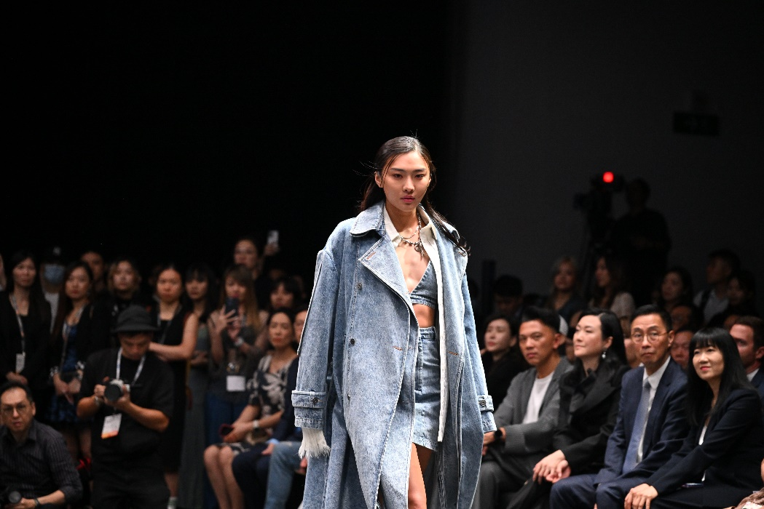
The exhibition featured multiple fashion shows and events, including CENTRESTAGE ELITES and the Fashion Hong Kong Runway Show. Multiple brands showcased their latest collections on stage. (Cecilia Yeung – wearing REDEMPTIVE outfit)
Various local fashion brands staged catwalks runway shows during CENTRESTAGE, including KOWLOON CITY BOY, Rickky Wong and Whatever Next.
The Hong Kong Kids Fashion Show featured a collection of internationally renowned brands.
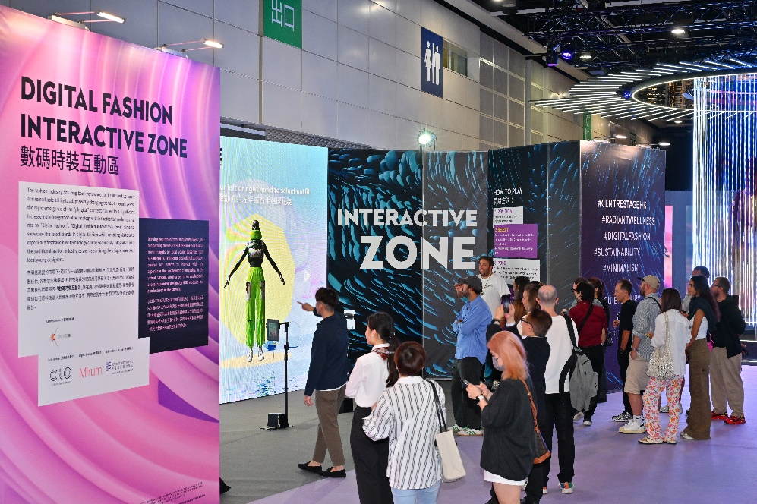
The fair was open to the industry and the public with free admission, offering a variety of experiences, including a Digital Fashion Interactive Zone that highlights a variety of fashion garments.

Websites:
CENTRESTAGE: www.centrestage.com.hk
Fashion Hong Kong: www.fashionhongkong.com.hk/en
Hong Kong Young Fashion Designers' Contest (YDC): www.fashionally.com/en
CENTRESTAGE ELITES: https://www.youtube.com/watch?v=QKXxxT8ZmD4

Media enquiries
For more information, please contact Best Crew
Diana Tang Tel: (852) 3594 6443 Email: diana.tang@bestcrewpr.com
Reni Kwok Tel: (852) 3594 6443 Email: reni.kwok@bestcrewpr.com

The HKTDC's Communications and Public Affairs Department
Katy Wong Tel: (852) 2584 4524 Email: katy.ky.wong@hktdc.org
Janet Chan Tel: (852) 2584 4369 Email: janet.ch.chan@hktdc.org

The HKTDC’s Media Room: http://mediaroom.hktdc.com/en

About HKTDC
The Hong Kong Trade Development Council (HKTDC) is a statutory body established in 1966 to promote, assist and develop Hong Kong's trade. With 50 offices globally, including 13 in Mainland China, the HKTDC promotes Hong Kong as a two-way global investment and business hub. The HKTDC organises international exhibitions, conferences, and business missions to create business opportunities for companies, particularly small and medium-sized enterprises (SMEs), in the mainland and international markets. The HKTDC also provides up-to-date market insights and product information via research reports and digital news channels. For more information, please visit: www.hktdc.com/aboutus. Follow us on Twitter and LinkedIn.

*Disclaimer: The Government of the Hong Kong Special Administrative Region provides funding support to the project only, and does not otherwise take part in the project. Any opinions, findings, conclusions or recommendations expressed in these materials/events (or by members of the project team) are those of the project organisers only and do not reflect the views of the Government of the Hong Kong Special Administrative Region, the Culture, Sports and Tourism Bureau, Create Hong Kong, the CreateSmart Initiative Secretariat or the CreateSmart Initiative Vetting Committee.

