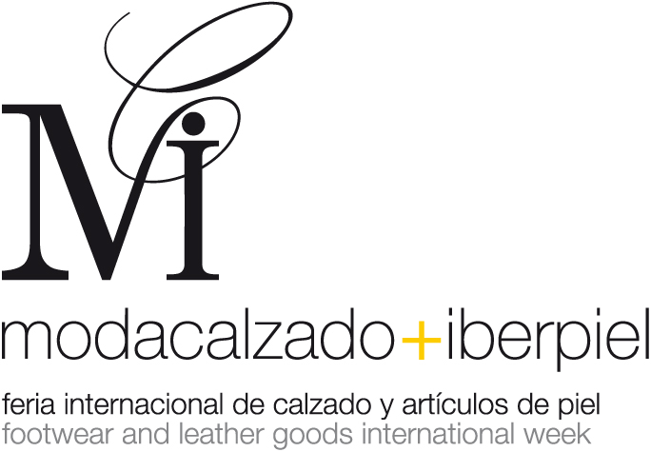

A climate of moderate optimism prevailed among the participating companies

MODACALZADO + IBERPIEL CONCLUDED ITS TWENTY-FIRST EDITION, HAVING WELCOMED SOME 14,557 REGISTERED PROFESSIONALS

- Out of the total number of visitors, 18 per cent attended the fair from abroad

MODACALZADO + IBERPIEL, the International Footwear and Leather Fashion Trade Fair, staged its twenty-first edition between 7th and 9th March within a climate of moderate optimism. This fair, which is considered to be one of the most important trade events for the industry in Europe, brought together the Autumn-Winter 2008/09 Collections of some 540 exhibiting companies at this edition. Some 423 of these companies were Spanish and 117 were foreign, featuring in a net exhibition area measuring 29,440 square metres.

The total number of visitors at the fair came to 14,557 professionals, a 15% decrease compared to the last edition. The fair's organisers believe that one of the main reasons for this decrease was the fact that a general election took place in Spain on Sunday 9th March. This much was demonstrated by the fact that public attendance at the event was higher over the first two days of the fair (Friday and Saturday) than at previous editions, whilst attendance fell on the last day. The impact of the elections was also reflected in the fact that the decrease in the number of visitors was higher among professionals from the most distant Spanish regions, such as the Balearic Islands, the Canary Islands, Catalonia and Galicia, and somewhat lower among buyers from Madrid and nearby regions. Another reason that led to a decrease in the visitor figure consists of the progressive fall in the number of multi-brand footwear outlets in Spain.

In spite of the fall in the number of visitors, the leading associations from the industry, such as the Spanish Footwear Industries Federation (FICE), the Association of Footwear Manufacturers of Elche (AICE), the Association of Footwear and Related Industries of La Rioja (AICCOR) and the Association of Footwear Related Manufacturers of the Balearic Islands (AFACA), considered the outcome of this edition to be favourable. The exhibitors who attended the event were also satisfied with their results. Thus, according to Javier Soler, the Marketing Manager of Martinelli, "the fair was excellent on Friday and Saturday, but weaker on Sunday". Similarly, Juan Carlos García, from the company, Corazón Azul, also rated the fair "favourably" whilst noting the varying levels of attendance on the part of the public. ´

Pascual Ros, the Marketing Manager at Mustang, stated that his company exceeded the sales figure it achieved at the March 2007 edition, stating that "we are completely satisfied". Magdalena Pons Quintana, the Manageress of Pons Quintana, expressed herself in similar terms: "The level of sales was good. Our customers and clients, who are loyal to our product, always search us out and make their purchases".

International Presence
Out of the total number of professionals who attended this edition of MODACALZADO + IBERPIEL, nearly 2,600 were from abroad, which is to say, approximately 18% of the total figure. Within this group, we might highlight the large number of Russian buyers present at this edition, given that the more than 40 guest buyers invited to the fair by IFEMA and the Madrid Chamber of Trade and Industry, were complemented by another large group from Russia, who attended the fair outside the Guest Buyer Programme. We might also highlight the strong level of attendance on the part of Portuguese professionals, who numbered 1,176 in total. Portugal occupies second place in the ranking of Spanish footwear exports, surpassed only by France. In this respect, we can observe that the habitually strong presence of buyers from Portugal at the fair was decisive in terms of guaranteeing the favourable performance of Spanish exports to the Portuguese market last year. Thus, the number of pairs of footwear sold to Portugal increased by 28 per cent, whilst the corresponding value figure increased by 14 per cent, and this was without the Spanish industry having carried out any other promotional measure in Portugal other than that implemented by MODACALZADO + IBERPIEL.

The strong attendance on the part of foreign visitors was also highly rated by various exhibitors. Thus, the Head of Communication and Image at Hispanitas, Amado González, confirmed the fact that the country's stand attracted buyers from markets as diverse as Germany, Israel and Russia. Furthermore, the company, Callaghan, also witnessed an increase in its foreign sales, featuring "large orders from Korea, Hong Kong, Saudi Arabia and Greece", according to Iván García, the Head of Design at the brand, who stated that he was "satisfied with the high standing of the professionals. MODACALZADO is always good for us".

The new layout presented in Hall 10, which featured the GLAMOUR and IBERPIEL sections, was also warmly received by both exhibitors and visitors. The wide avenues crossing the hall and the terraces, as well as the live music and the CalzArte Photography Exhibition all helped to create a buoyant atmosphere within this part of the fair.

Fashion Trends
As far as trends are concerned, the more than 740 participating companies confirmed a series of tendencies for Autumn-Winter 2008/09: high heels will feature prominently, based on a large number of conical forms, whilst platforms will also remain popular, in the same way as ballet-style shoes. Among the new features, we might highlight peep- toe or open-toe boots, and those that feature an incorporated sock, along with musketeer boots. As far as materials are concerned, exotic varieties of leather such as snakeskin, ostrich and crocodile skin will play a leading role throughout the new season, alongside patent leather featuring multiple effects - wrinkled, patterned, etc. Rabbit fur will be used to line footwear both inside and out. With regard to bags, although oversized formats will prevail, smaller formats will begin to gain ground.

The predominant colours will be grey, green, brown, intense blue and certain fluoride touches. Leather textures will be smooth and we will come across patent leather finishes featuring multiple effects (wrinkled, etc), not to mention combinations of leather and textiles (wool, Lycra, velvet, etc). Furthermore, the most frequently-used adornments will include varnished metal, zips and technological textiles.

Companies as prestigious as Pura López, Sara Navarro, Jaime Mascaró, Pons Quintana, Chie Mihara, Pedro García, Dorotea, Paco Gil, Ras, Magrit, Ras and Alima, once again surprised visitors to the fair with their collections packed with design, fashion and innovation. Under the heading of leather goods and items, brands such as Miguel Bellido, Superga, Converse and O'Neill exhibited their latest creations, based on the latest trends.

The next edition of MODACALZADO + IBERPIEL will take place between 25th and 27th September 2008 at Feria de Madrid. On this occasion, the exhibitors will present their collections for Spring-Summer 2009.

Madrid, 18th March 2008

For further information:
Marietta Vázquez, International Press
Tel:. +34 91 722 51 74
Fax: +34 91 722 57 93
E-mail: marieta@ifema.es
Internet: www.prensa.ifema.es

www.fotoprensa.ifema.es

